Assignment 1
​​1DV503 Database Technology
Kaja Gülzau
School of Computer Science, Physics
and Mathematics, Linnaeus University, Sweden
kg222tj@student.lnu.se

Part 1

Task 1 Music Streaming Service Database (15 points)
1.1 Identify all entities and their attributes from the description of database requirements using the following Table template:
Entity | Attribute | Attribute Type | Is a Key Attribute? | The value type of attributes and constraints (data type, NULL/NOT NULL, Unique)
User | User-ID | Simple | Yes | Unique, String, not null
User | Birthday | Simple | No | Date (YYYY-MM-DD), null
User | Profile Image | Simple | No | String (url path), null
User | Password | Simple | No | String, not null
User | Email | Simple | Yes | Unique, String, not null
User | Full Name  (FirstName and LastName) | Composite | No | String, not null
Subscription (weak) | Subscription-ID | Simple | Yes | Unique, String, not null
Subscription (weak) | Type | Simple | No | String, free or premium, not null
Playlist | Playlist creation Date | Simple | No | Date (YYYY-MM-DD), not null
Playlist | Playlist-ID | Simple | Yes | Unique, String, not null
Playlist | Playlist Name | Simple | No | String, not null
Artist | Artist-ID | Simple | Yes | Unique, String, not null
Artist | Artist Name | Simple | No | String, not null
Artist | Genre | Multi-valued | No | String, null
Artist | Artist Image | Simple | No | String (url path), null
Album | Album-ID | Simple | Yes | Unique, String, not null
Album | Album Title | Simple | No | String, not null
Album | Album Release Date | Simple | No | Date (YYYY-MM-DD), not null
Album | Album Image | Simple | No | String (url path), null
Track | Track-ID | Simple | Yes | Unique, String, not null
Track | Track title | Simple | No | String, not null
Track | Duration | Simple | No | Int, not null

1.2 Identifying the relationship between entities defined in Task 1.1 using the following table template:

Entity A | Relationship name | Entity B | Cardinality Ration  (1:1, 1:N, N:1, M:N) | Attribute of Relationship  (optional) | Justify your decision for the cardinality ratio  (mandatory)
User | Has | Subscription | 1:1 | Subscription Start Date, Subscription End Date | Every user can only have one subscription at a time and every subscription can only belong to one user
User | Creates | Playlist | 1:N |  | A user can create one or several playlists and each playlist only belongs to one user, however this relationship could also be M:N if the music streaming service allows several users to create a playlist together
Playlist | Includes | Track | M:N |  | Playlist can include zero or several tracks, Track can be in several or no playlists
Track | Belongs_To | Album | M:N |  | Track can be part of several or no albums, Albums can include one or more tracks
Artist | Releases | Album | M:N |  | Artist can release zero or several albums, Albums belong to one or more artists
Artist | Is | User | 1:1 |  | Every artist is also a user and every user account can only belong to one artist

1.3 Design an ER schema for the music streaming service database based on information provided in task 1, and entities defined in 1.1 with relationships defined in 1.2.

Note: Artist-ID and Playlist-ID are key attributes and Subscription-ID a partial key attribute, but the website kept removing the underline, despite me selecting the “key attribute” / ”weak key attribute” type. I tried several times to fix this issue, but even me manually marking the text and selecting the “underline” option did not work, the website would immediately remove it. When selected, the attribute still shows up underlined, it just changes as soon as I click away from it. I have added a screenshot of an example of this in order to clear up any confusion.
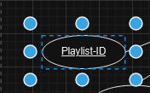

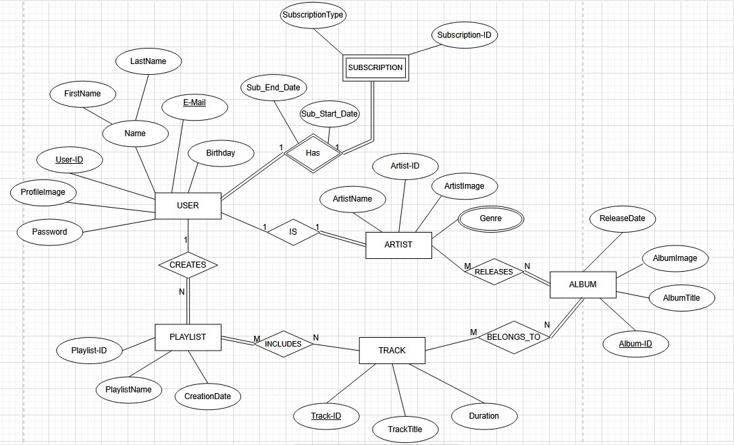

Task 2 University Social Network Database (15 points)
2.1 Identify all entities and their attributes from the description of database requirements using the following Table template:

Entity | Attribute | Attribute Type | Is a Key Attribute? | The value type of attributes and constrains (data type, NULL/NOT NULL, Unique)
Student | Student-ID | Simple | Yes | Unique, String, not null
Student | StudentName  (FirstName, LastName) | Composite | No | String, not null
Student | E-Mail | Simple | Yes | Unique, String, not null
Student | Password | Simple | No | String, not null
Student | Birthday | Simple | No | Date (YYYY-MM-DD), not null
Student | Hobby | Multivalued | No | String, null
Student | Gender | Simple | No | String, not null
Student | StudyProgram | Simple | No | String, not null
Student | JoinDate | Simple | No | Date (YYYY-MM-DD)
Student | StudentImage | Simple | No | String (url path), null
Study_Group | Group-ID | Simple | Yes | String, Unique, not null
Study_Group | GroupName | Simple | No | String, not null
Study_Group | GroupSubject | Simple | No | String, not null
Study_Group | CreationDate | Simple | No | Date (YYYY-MM-DD), not null
Event | Event-ID | Simple | Yes | String, Unique, not null
Event | EventName | Simple | No | String, not null
Event | EventDescription | Simple | No | String, not null
Event | EventAddress (Street, PostalCode) | Composite | No | String, not null
Event | EventDate | Simple | No | Date (YYYY-MM-DD), not null
Event | EventTime | Simple | No | String (Time), not null
Post | Post-ID | Simple | Yes | String, Unique, not null
Post | PostText | Simple | No | String, not null
Post | PostImage | Simple | No | String (url path), null
Post | PostLocation | Simple | No | String, null
Post | PostDate | Simple | No | Date (YYYY-MM-DD), not null

2.2 Identifying the relationship between entity sets using the following table template:

Entity A | Relationship name | Entity B | Cardinality Ration  (1:1,1:N,N:1,M:N) | Attribute of Relationship  (optional) | Justify your decision for the cardinality ratio  (mandatory)
Student | Befriends | Student | N:M | Status, Start_Date | Every student can have several friends
Student | Creates | Study_Group | 1:N |  | Student can create more than one study group, but a study group can’t be created by more than one student
Student | Joins | Study_Group | M:N | GroupJoinDate | Students can join several study groups and study groups can have more than one student in them
Student | Hosts | Event | 1:N |  | Students can host several events, but there can only be one host per event  Note: This could also be M:N if the university social network allows several students to host events together, I simply decided on 1:N to make it easier
Student | Writes | Post | 1:N |  | Students can create more than one post, but posts can’t have more than one author
Student | Comments_On | Post | M:N | CommentText | Students can comment on more than one post and a post can have comments from more than one student

2.3 Design an ER schema for the university social network database based on information provided in task 2, and entities defined in 2.1 with relationships defined in 2.2.
Note: I ran into the same problem as in task 1.3, Group-ID, Event-ID and Post-ID are supposed to be underlined key attributes.
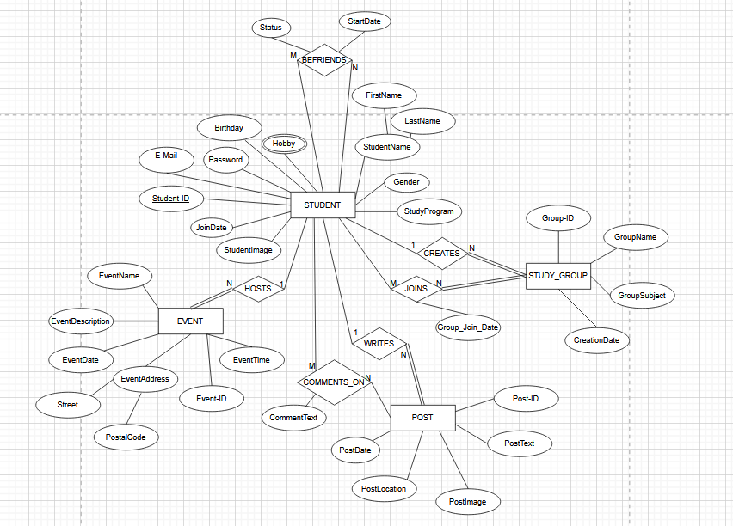

Task 3 Airport Management Database (10 points)

3.1 Given the constraints shown in the ER schema below, respond to the following statements with True, False, or Maybe.

N | Statement | True/False/Maybe | Justify your answer (mandatory)
1 | Every pilot has been a passenger on at least one flight. | Maybe  (or False) | The pilot only has partial participation in being a passenger or deadheading a flight, which points to the answer being “False”. However, from a realistic standpoint, it is very likely that every pilot has been a passenger on at least one flight, even just as part of their (or another pilot’s) training. Due to this reason, I decided to answer “Maybe”.
2 | Every flight has at least one deadheading pilot | False | The “Deadheading” relationship only has partial participation from both the pilot and the flight.
3 | Every flight has 2 pilots. | False/Maybe | The flight has total participation in the “Flies” relationship and therefore has at least one pilot and a maximum of two.  Legal requirements call for two pilots per flight for most airplanes, but in case of a very small aircraft it would be allowed to have only one pilot (https://flygv.com/blog/the-importance-and-benefits-of-utilizing-dual-pilot-operations), so the answer depends on what kind of aircrafts are being handled by this database. Assuming any size of aircraft is included, the answer would be “False” but considering the fact that all the aircrafts are owned by airlines (see the circular dependency of the “owns” relationship) instead of also being private jets, which tend to be smaller, it is highly probable that all the aircrafts are big enough to require two pilots.  Without having more information on the type of aircrafts, it is not possible to give a definitive answer, which is why I also included “Maybe” as an answer.
4 | Each flight must have an assigned departure and arrival airport. | True | The flight has total participation in both the “Arrival” and “Departure” relationship.
5 | Every pilot has flown at least 2 times | False | There is no information on the minimum amount of flights a pilot has to have made, only the maximum (n --> no limit), a pilot could be doing their first flight
6 | Some tickets that do not belong to any flight | False | Tickets have total participation in the “Belongs To” relationship, so they have to belong to a flight
7 | Some airlines do not have flights. | False | Airlines have total participation in the “Belong To” relationship, so they have to have at least one flight
8 | A passenger can be a pilot. | True | The “Is A” relationship has partial participation for both the pilot and the passenger, so a passenger CAN (but doesn’t have to be) a pilot and the same is true in reverse.
9 | Some tickets do not belong to any class type (Economy, Business, etc.) | False | Tickets have to have a class due to having total participation in their relationship to “Class”
10 | Some tickets are without payment | True | Tickets have partial participation in the “Receives” relationship and therefore don’t necessarily have to have a payment

3.2 List the (min, max) constraint using the total/partial participation for the Ticket entity. Justify your answer.

Entity | Relation | (min,max) | Explanation
Payment | Receives | (1,1) | The payment has total participation (min: 1) in the 1:1 (max: 1) relationship with the ticket
Ticket | Receives | (0,1) | The ticket only has partial participation (min: 0), the max constraint stays the same
Flight | Belongs To | (1, N) | The flight has total participation (min: 1) and a 1:N cardinality ratio (max: N)
Ticket | Belongs To | (1, 1) | The ticket has full participation (min: 1), but is on the other side of the relationship, so the “1” from the cardinality applies (max: 1)
Class | Has | (0, N) | The class has partial participation (min: 0) and a 1:N cardinality (max: N)
Ticket | Has | (1, 1) | The ticket has full participation (min: 1) and is on the other side of the cardinality (max: 1)
Passenger | Book | (0, N) | The passenger has partial participation (min: 0) and a 1:N cardinality (max: N)
Ticket | Book | (1, 1) | The ticket has full participation (min: 1) and is on the other side of the cardinality (max: 1)

Part 2

Task 4. Conver ER model to Relational Model (15 points)
Note: I combined “User” and “Subscription” into one table according to slide 12 of lecture 4, since it was a circular dependency. I tried to follow the example from the slide, which is why I wrote “SUBSCRIPTION” and left out the primary key (“Subscription-ID”) of the subscription entity.
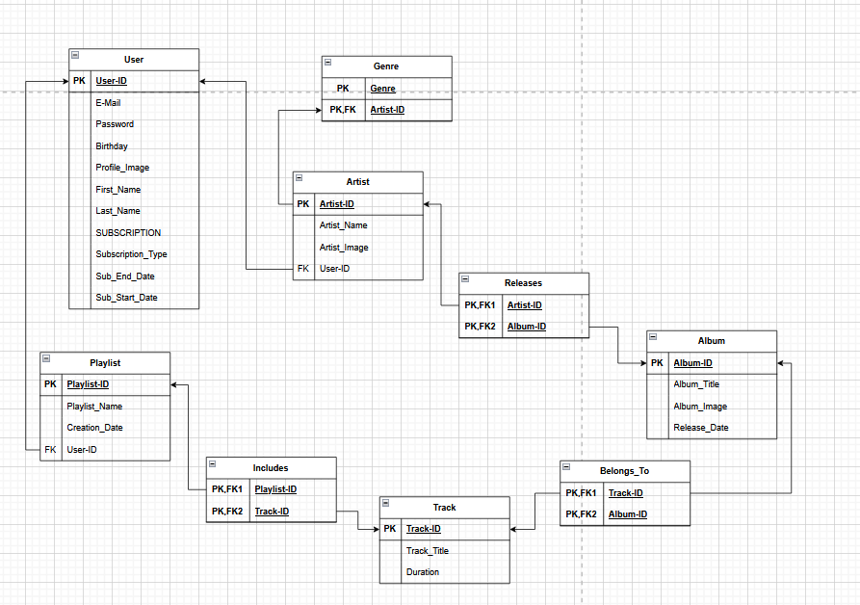

Task 5 Normalisation (15 points)

5.1 Considering unnormalized Pizzeria database with one table is shown below on image below, perform normalisation to achieve 3NF for all tables.

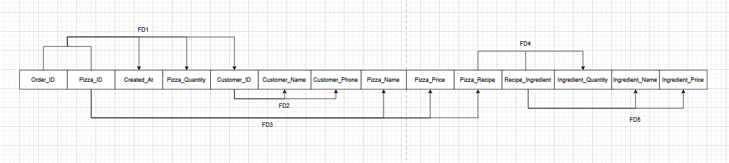
Unnormalized database:

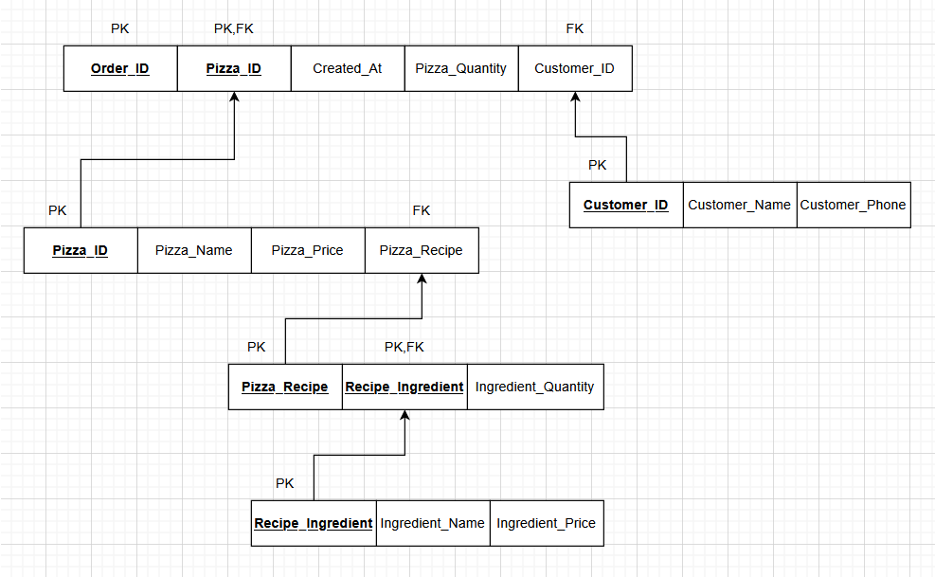
Normalized version:

5.2 Consider adding pizza size (small, medium, large) attribute to the Order table, and the pizza price will be different for each pizza size. Make sure that changes and new tables satisfy the 3NF.

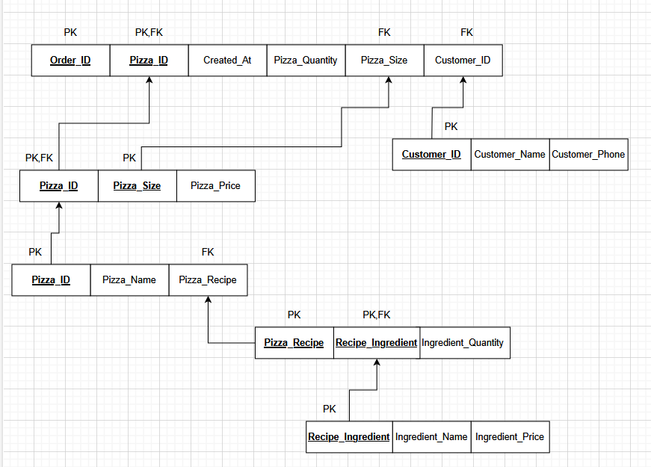

Part 3

Task 6. Basic SQL queries (20 points)

Query | Answer
1.1 retrieves all artists whose names start with the same letter as the first letter of your first name. | SELECT Artist.Name  FROM Artist  WHERE Artist.Name LIKE 'K%';  Rows: 4
1.2 retrieves all tracks by “BackBeat” artists. | SELECT Track.Name, Artist.Name AS artist  FROM Track  JOIN Album ON Track.AlbumId=Album.AlbumId JOIN Artist ON Album.ArtistId=Artist.ArtistId  WHERE Artist.Name='BackBeat';  Rows: 12
1.3 lists all album titles along with their respective artist name. | SELECT Album.Title, Artist.Name  FROM Album  JOIN Artist ON Album.ArtistId=Artist.ArtistId;  Rows: 347
1.4 Lists the total number of tracks in each album, sorted by total in descending order. | SELECT Album.Title, Count(Track.Name) AS Total_Tracks  FROM Album  JOIN Track ON Album.AlbumId=Track.AlbumId  GROUP BY Album.Title  ORDER BY Total_Tracks DESC;  Rows: 347
1.5 finds tracks with “Protected AAC audio file” media type | SELECT Track.Name, MediaType.Name  FROM Track  JOIN MediaType ON Track.MediaTypeId=MediaType.MediaTypeId  WHERE MediaType.Name='Protected AAC audio file';  Rows: 237
1.6 Lists all tracks from “Big Ones” album | SELECT Track.Name, Album.Title  FROM Track  JOIN Album ON Track.AlbumId=Album.AlbumId  WHERE Album.Title='Big Ones';  Rows: 15
1.7 finds the total duration of tracks in each playlist. You'll need to use the Playlist, PlaylistTrack, and Track tables for this. | SELECT Playlist.Name, SUM(Track.Milliseconds) AS Total_Duration  FROM Playlist  JOIN PlaylistTrack ON Playlist.PlaylistId=PlaylistTrack.PlaylistId JOIN Track ON PlaylistTrack.TrackId=Track.TrackId  GROUP BY Playlist.Name  ORDER BY Total_Duration DESC;  Rows: 12
1.8 finds the 10 most expensive tracks. | SELECT Track.Name, Track.UnitPrice  FROM Track  ORDER BY Track.UnitPrice DESC  LIMIT 10;  Rows: 10
1.9 finds the list of artists who do not have any albums. | SELECT Artist.Name  FROM Artist  WHERE NOT EXISTS (SELECT * FROM Album WHERE Artist.ArtistId=Album.ArtistId);  Rows: 71
1.10 lists all playlists and the number of tracks in each. | SELECT Playlist.Name, Count(PlaylistTrack.TrackId) AS Total_Tracks  FROM Playlist  JOIN PlaylistTrack ON Playlist.PlaylistId=PlaylistTrack.PlaylistId  GROUP BY Playlist.Name;  Rows: 12

Task 7. Advanced SQL queries (10 points)

Query | Answer
2.1 finds albums with multiple genres.
2.2 identifies customers with the highest average invoice value. | SELECT Customer.FirstName, Customer.LastName, AVG(Invoice.Total) AS Average_Invoice  FROM Customer  JOIN Invoice ON Customer.CustomerId=Invoice.CustomerId  GROUP BY Customer.LastName  ORDER BY Average_Invoice DESC;  Rows: 1
2.3 Find the Longest Playlist by Duration. | SELECT Playlist.Name, SUM(Track.Milliseconds) AS Total_Duration  FROM Playlist  JOIN PlaylistTrack ON Playlist.PlaylistId=PlaylistTrack.PlaylistId JOIN Track ON PlaylistTrack.TrackId=Track.TrackId  GROUP BY Playlist.Name  ORDER BY Total_Duration DESC  LIMIT 1;  Rows: 1
2.4 finds customers with Maximum Purchase in Each Country.
2.5 find the most popular album purchased by each country. Order the results by number of Sales in descending order. Print the country, album name, and maximum sales

OBS! DO NOT FORGET ALSO TO SUBMIT THE .SQL SCRIPT FILE CONTAINING ALL SQL QUERRIES

